Pablo Endara

**Note on Data Structures in Python**

**Arrays:**

A collection of elements / Values each identified by an array index or key

* Index starts at Zero
* if the index we are able to select items randomly

Multidimensional Array: it can prove to be very important in mathematical related computations ( matrixes )

* Arrayed are used to store items of the same type
* Uses indices as keys
* Arrays can have as many dimensions as we want
* Dynamic array: when the size of the array is changing dynamically
* Applications: lookup tables / hashtables, heaps

**Advantages**

* Can use random access because of the keys: and it will return that value very fast
* Very easy to implement and use
* Very fast data structure
* We should use arrays in apps when we want to add items over and over again and we want to take items with given indexes!! ~ it will be very fast

**Disadvantages**

* We have to know the size of the array at complie time – so it is not so dynamic data structure
* If it is full: we have to create a bigger array and have to copy the values one by one

// reconstructing an array is **O(N)** operations

* It is not able to store item with different types

**Array Operations**

1. Remove or change item from array // **O(N)**
   1. It is not that simple, we may have to shift items

**Linked Lists**

Linked lists are composed of nodes and references / pointers pointing from one to the other

The last reference is pointing to a NULL

A single node:

* Contains data -> integer, double, or custom object
* Contains a reference pointing to the nect node in the linked list

Class Node {

Data

Node nextNode

}

* Each node is composed of data and a reference / link to the next node in the sequence
* Simple and very common data structure
* They can be used to implement several other common data type: stack, queues
* Simple Link List by themselves do not allow random access to the data
  + So we cannot use indexing
* Many basic operations such as obtaining the last node of the list or finding a node that contains a given data or locating the place where a new node should be inserted – require sequential scanning of most or all of the list elements

**Advantages**

* Linked list are dynamic data structure (arrays are not)
* It can allocate the needed memory in run-time
* Ver efficient if we want to manipulate the first element
* EASY IMPLEMENTATION
* Can store items with different sizes: an array assumes every element to be exactly the same
* Its easier for a link list to grow organically. An array size needs to be known ahead of time, or re-create when it needs to grow

**Disadvantages**

* Waste memory because of the references
* Nodes in a linked list must be read in order from the beginning as linked list have sequential access ( array items can be reached via indexes in **o(1)** time)
* Difficulties arise in linked list when it comes to reverse traversing. Singly linked list are extremely difficult to navigate backwards
* Solution: double linked list -> easier to read, but memory is wasted in allocating space for a back pointer

**Linked List Operations**

**Insertion**

Inserting items at the beginning of a linked list: very simple, we just have to update the reference -> O(1) time complexity

linkedList.insertAtStart(4)

we just have to set the pointer to point to the next node

Inserting items at the end of the linked list: not that very simple, we have to traverse the whole linked list to find the last node

How do we find the last node?

We know that the last node is pointing to NULL

We have to update the reference when we get there O(N) time complexity

Insert at the beginning O(1)

Inserting at the end O(N)

**Remove**

Removing item at the beginning of the list is always very fast: we do not have to search for the item, we just have to update the reference accordingly O(1) time complexity

Removing item at a given point of the list is not very fast: we have to search for the location of the item, which may time some time, O(N) time complexity

**Linked List vs Arrays:**

1. Search
   1. Search operations yields the same result for both data structures
   2. Arraylist search operations is pretty fast compared to linked list search operation
      1. We can use random access: whish is O(1) time
   3. Linked list performs is O(N) time
      1. Conclusion ArrayList is better
      2. Why?
         1. ArrayList maintains index bases system for its elements as it uses array data structure implicity which makes it faster for searching an element in the list
         2. While linkedList requires traversal through the entire items for searching an element
2. Deletion
   1. Linkedlist removes operations takes O(1) time if we remove items from the beginning and usually this is the case
   2. ArrayList: removing first element ( so at the beginning ) takes O(N) time, removing the last item takes O(1) time
      1. But on average: we have to reconstruct the array when removing
   3. So the conclusion: LinkedList is better for this operation
      1. Why?
         1. Linkedlist basically operation with pointers: removal only requires change in the pointer location which can be done very fast
3. Memory Management
   1. Array do not need any extra memory
   2. Linkedlist on the other hand do need extra memory because of the reference / pointers
   3. So in this aspect: array are better, they are memory friendly

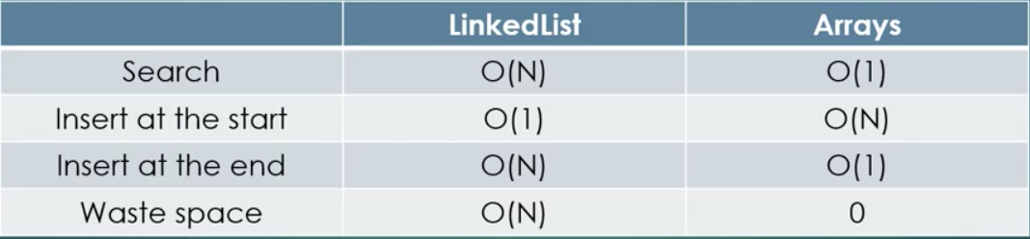

**Double LinkedList**

Double linked list are compose of nodes ans reference / pointers pointing from one node to the other

The last and first reference are pointing to Null

* We can access the head
* We can assess the tail

A Single Node:

* Contains data -> integer, double or custom object
* Contains a reference pointing to the next node in the linked list
* Contains a reference pointing to the pervious node in the linked list

Class Node {

Data

Node nextNode

Node perviousNode

}

**Advantages of double linked list:**

* A Double linked list can be traversed both directions: forward and backward
* The removal operation is more efficient if the node is given
  + For linked list we need the previous node as well. To find it usually we need to traverse the whole list
* To remove a Node from a single linked list -> we node the node + predecessor
* To remove a node from a double linked list -> we need the node

**Stack**

* It an abstract data type (interface)
* Basic operations pop(), push() and peak()
* **LIFO** structure: last in first out
* A stack and be easily implemented either with array or linked list
* A number of programming languages are stack-oriented, meaning they define most basic operations as taking their argument from the stack, and placing any return values back on the stack

Push operation: put the given item to the top of the stack

Very simple operation, can be done in O(1)

Pop operation: we take the last item we have instead to the top of the stack (LIFO)

Very simple operation can be done in O(1)

Peek operation: return the item from the top of the stack without removing it

Very simple operation, can be done in O(1)

**Stack applications:**

* In stack-oriented programming languages
* Graph algorithms: depth-first search can be implemented with stack ( or with recursion)
* Finding Euler-cycle in a graph
* Finding strongly connected components in a graph

**Stack** ,,call stack”

* Most important application of stack: stack memory
* It is a special region of the memory (in the RAM)
* A call stack is an abstract data type that stores information about the active subroutines / methods / functions of a computer program
* The details are normally hidden and automatic in high-level programming languages
* Why it is good?
* It keeps track of the point to which each active subroutine should return control when it finishes executing
* Stores temporary variables created by each function
* Every time a function declares a new variable it is pushed onto the stack
* Every time a function exit all of the variables – pushed onto the stack by that function are – freed -> all of its variables are popped off the stack // and lost forever!!
* Local Variables: they are on the stack, after function returns they are lost
* Stack memory is limited!!!

**Heap memory:**

* The heap is a region of memory that is not managed automatically for you
* This is a large region of memory // unlike stack memory
* **C:** malloc() and calloc() function // with pointers
* **Java:** reference types and objects are on the heap
* we have to deallocated these memory chunks: because it is not managed automatically
* if not: memory leak!!!’
* slower because of pointers

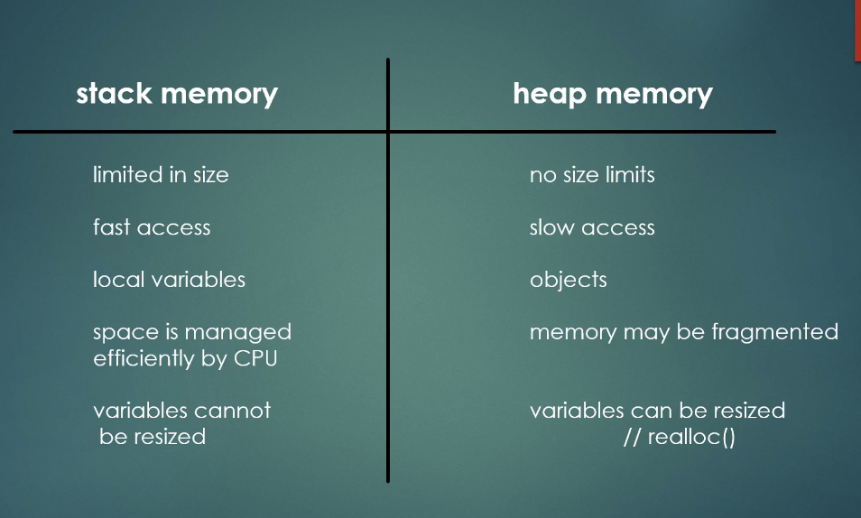

**Stack and recursion**

* there are several situations when recursive methods are quite handy
* For example: DFS, traversing binary search tree, look for an item in a linked list….
* What’s happening in the background?
* All the recursive algorithms can be transformed into a simple method with stack
* IMPORTANT: if we used recursion, the OS will use stacks anyways!!

**Queue**

* It is an abstract data type (interface)
* Basic operations: enqueue() and dequeue(), peak()
* FIFO structure: first in first out
* It can be implemented with dynamic arrays as well as with linked list
* Important when implementing BFS algorithm for graphs

Enqueue operation: we just simply add the new item to the end of the queue

Done in O(1)

Dequeue operation: we just simply remove the item starting at the beginning of the queue // FIFO structure

Queue Applications:

* When a resource is shared with several consumers ( threads ): we store them in a queue
* For Example: CPU scheduling
* When data is transferred asynchronously (data not necessarily received at same reate as rent) between two processes
* For example: IO buffers
* Operational research applications or stochastic models relies heavily on queues

**Trees**

We have nodes with the data and connection between the nodes

Root Nodes: We have a reference to this, all other nodes can be accessed via the root node

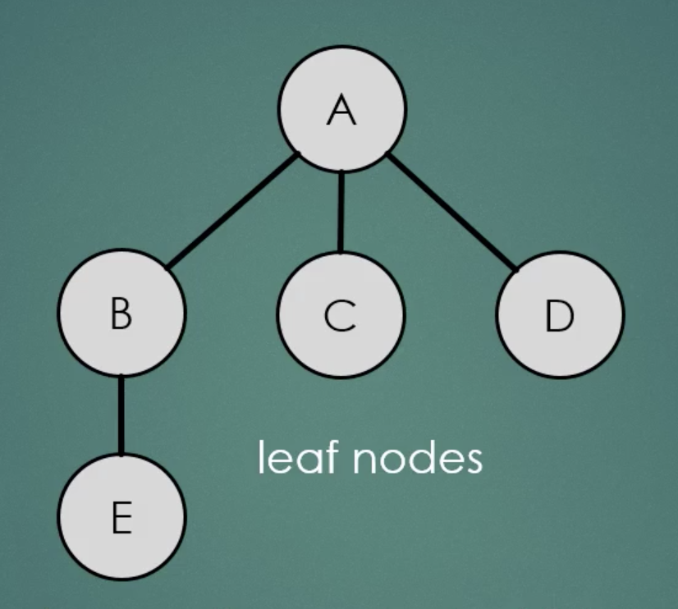

A Node directly connected to the another node -> Child

The opposite -> Parent

Leaf Node: Node with no children

Binary Search Tree:

* Every node can have at most 2 child nodes ( left and right)
* Left Node: Smaller than Parent Node
* Right Node: Bigger than Parent Node

Why is this good?

In every decision we get rid of half of the data in which we are searching!!

**O(LogN) Time Complicity**

Height of the tree: the number if layers it contains

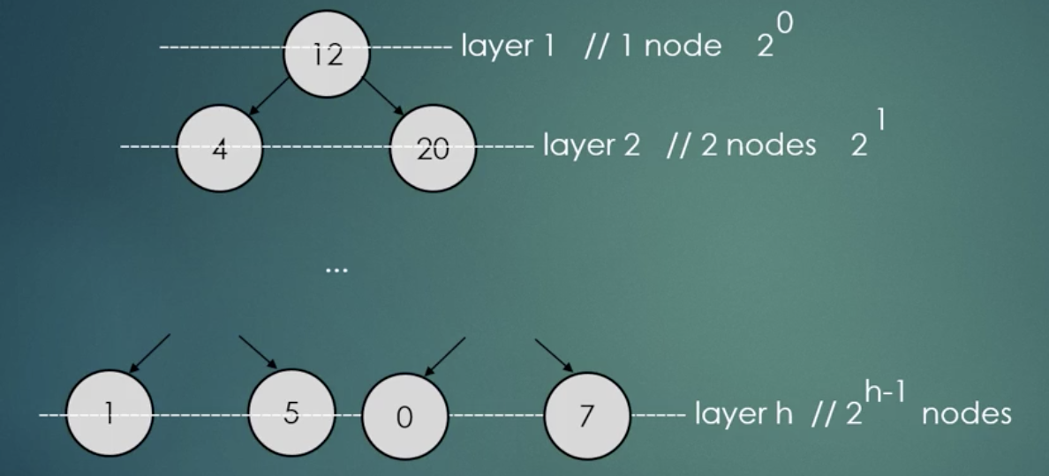

In general: H ~ **O(logN)** if this is true the tree is said to be balanced if it is not true the tree is unbalanced, which means it is asymmetric which is a problem!!!

Binary search tree

* Binary search trees are data structure
* Keep the key in sorted order: so that look up and other operations can use the principal of binary search
* Each comparison allows the operation to skip over half of the tree, so that each look up/ insertion/deletion takes time proportional to the logarithm of the number of items stored in the tree
* This is much better than the linear time O(N) required to find items by key in an unsorted array, but slower than the corresponding operations on hash tables

Insertion: we start at the root node. If the data we want to insert is greater than the root node we go to the right if it is smaller we go to the left and so on….

Search: we start at the root node. If the data we want to find is greater than the root node we go to the right, if it is smaller, we go to the left until we find the node

Delete: soft delete -> we do not remove the node from the BST we just mark that it has been removed ~ not so efficient solution

The main **three** possible cases:

1. The node we want to get rid of is a left node: Very simple, we just have to remove it ( set it to null )
   1. Complexity: we have to find the item itself + we have to delete it or set it to NULL ~ **O(logN)** find operation + **O(1)** deletion = **O(logN)**
2. The node we want to get rid of has a single child, we just have to update the reference
   1. Complexity: we have to find the item we want to get rid of and we have to update the reference ~ set the parent pointer point to its grandchild directly ~ **O(logN)** find operation + **O(1)** update references = **O(logN)**
3. The node we want to get rid of has 2 children
   1. We have two options: we look for the largest item in the left subtree or the smallest item in the right subtree
   2. We look for the predecessor and swap the two nodes
      1. We end up at case 1) situation: we just have to set it to null
   3. Time Complexity: **O(logN)**

Traversal: sometimes it is necessary to visit every node in the tree, we can do it several ways

1. In – order traversal: we visit the left subtree + the root node + the right subtree recursively

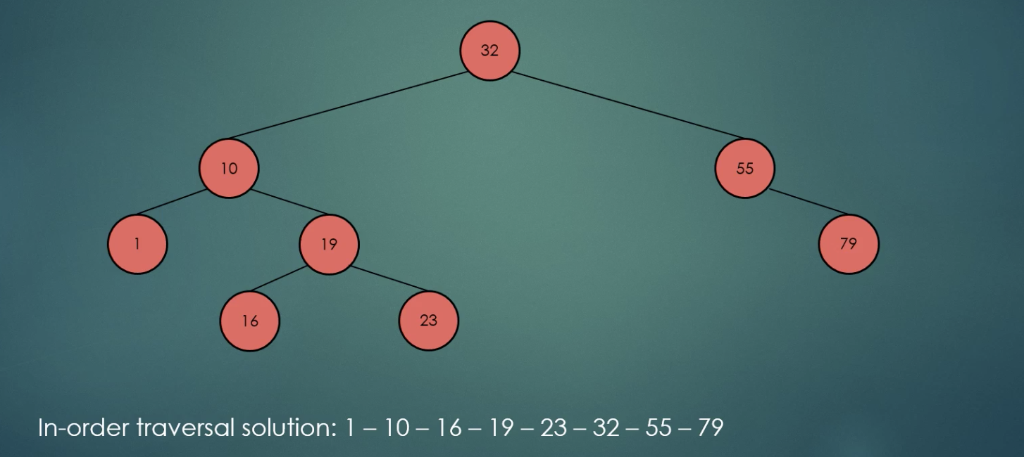

1. Pre-order traversal: we visit the root + left subtree + the right subtree recursively

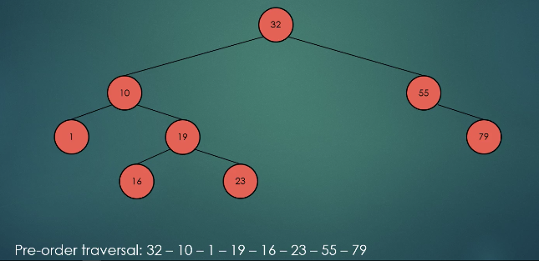

1. Post-order traversal

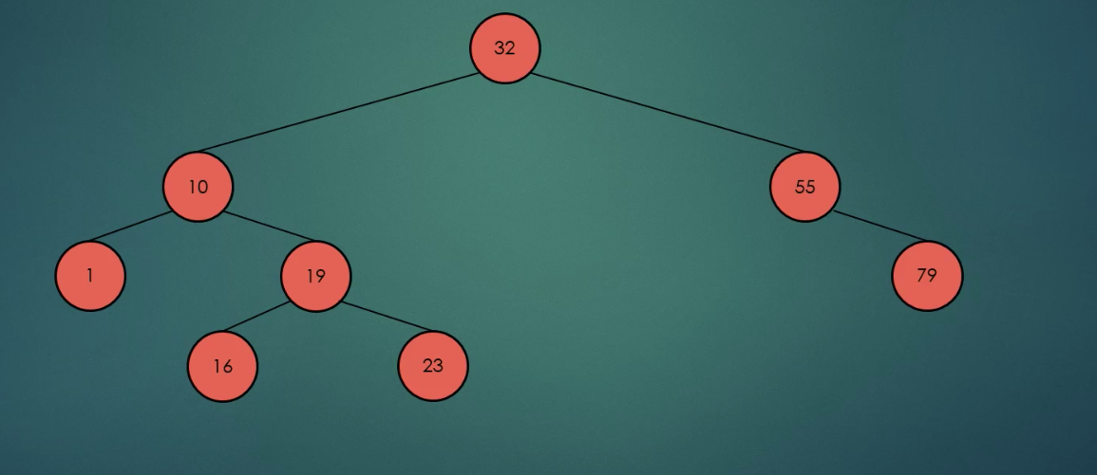

Post order traversal: 1, 16, 23, 19, 10, 79, 55, 32

Running times for Binary Search Trees

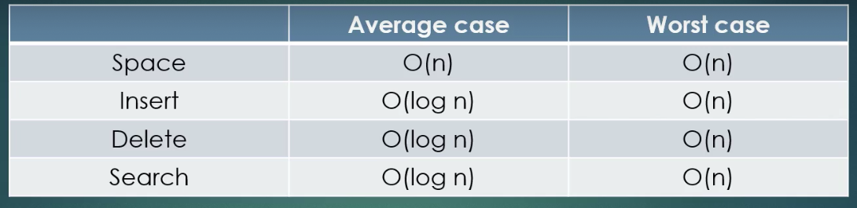

What about the worst Case:

* If the Tree becomes unbalanced: the operations running times can be reduced to **O(N)** in the worst case
* That’s why it is important to keep a tree as balanced as possible

Tree Applications:

Operation system uses almost all the important data structures. Let’s talk about the real-world applications of a **Trees:**

1. Tree are extremely powerful if we want to represent hierarchical data (file system)
   1. Operating systems’
   2. Game Trees (chess and Tic Tac Toe)
   3. Machine Learning: we like decision trees and boosting use very simple tree structures

**AVL Trees:**

* **Linked List:** Easy to implement, Stores a lot of pointers, **O(N)** search operation time
* **Binary Search Trees:** We can come to the conclusion that **O(N)** Search complexity can be reduced down to **O(log(N))** if the tree is balanced, if not these operations will become slower and slower
* **Balanced Binary Search Tree:** AVL trees or red-black tree, they are guaranteed to be balanced: **O(log(N))** is guaranteed

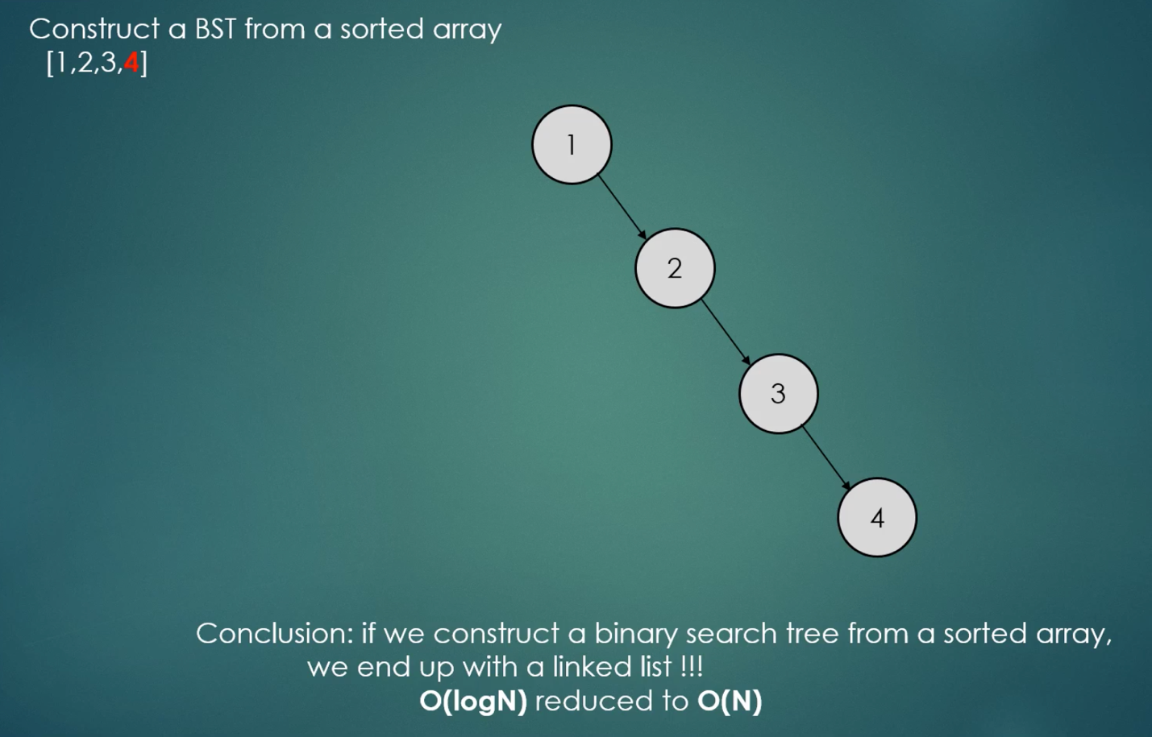

* The running time of BST operation depends on the height of the binary search tree: we should keep the tree balanced in order to get the best performance
* That’s why AVL tree come to be
* 1963: invented by two Russian computer scientists
* In an AVL Tree, the heights of the two-child subtree of any node differ by at most one
* Another solution to be problem is a red-black tree
* AVL tree are faster than red-black tree because they are more rigidly balanced BUT needs more work
* Operating systems relies heavily on these data structures
* Most of the operations are the same as the BST
* Every node has at most two child nodes: left is small then root and the right is greater than the root
* The Insertion operation is the same BUT on every insertion, we have to check wheather the tree is unbalanced or not
* Deletion operation is the same
* Maximum / Minimum finding operation are the same as well

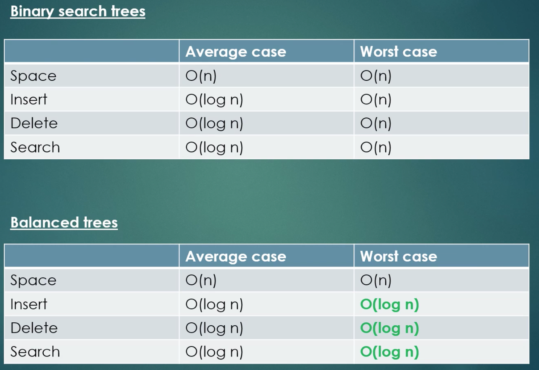

Height of a node: length of the longest path fromn it to a leaf

We can use recursion to calculate it:

Height = max(leftChild.height(), righChild.height()) + 1

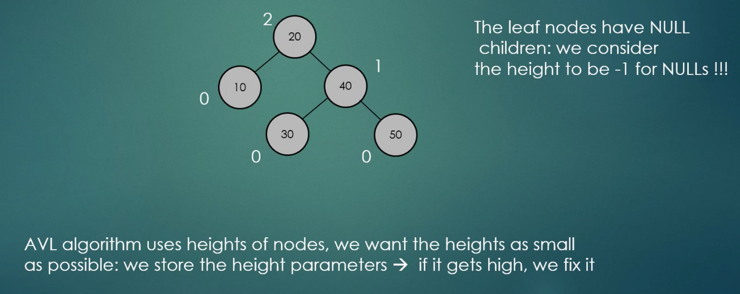

* AVL Trees require the height of left and right child of every node to differ at most +1 or -1
* | height(left Subtree) – height(right Subtree) | < 1
* We can maintain this property in O(log(N)) time which is quite fast
* Insertion:
  + A simple BST insertion according to the keys
  + Fix the AVL property on each insertion from insertion upward
* There may be several violations of AVL property from the inserted node up to the root
* We have to check them all

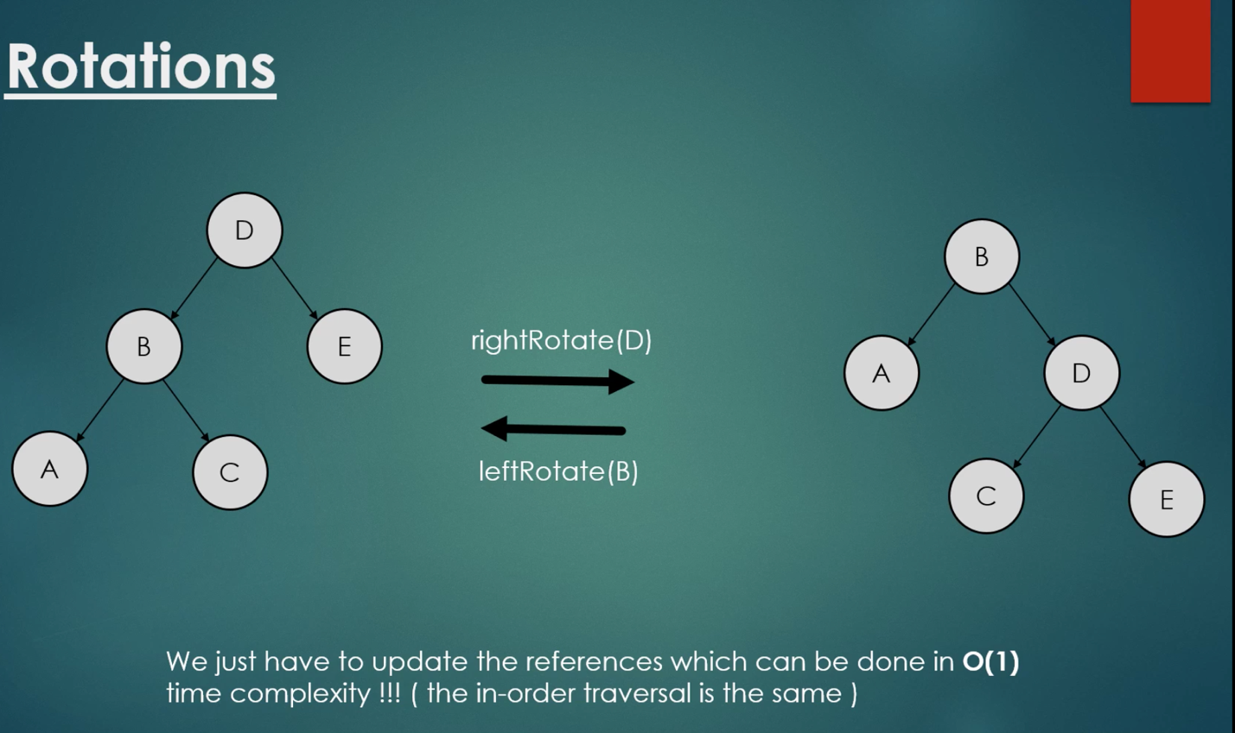

**AVL sort:**

* We can use this data structure to sort items

Insertion: O(N*logN)

In-order Traversal: O(N)

Overall Complexity: **O(N*log(N))**

* The running time of BST operations depends on the height of the binary search tree: we should keep the tree balanced in order to get the best performance
* In an AVL tree, the height of the two child subtrees of any node differ by at most one
* Another solution to the problem is red and black trees
* AVL trees are faster than red-black trees because they are more rigidly balanced BUT needs more work
* Operating Systems relies heavily on these data structures

**Red Black Trees:**

Red-Black properties:

* Each node is either red or black
* The root node is always **Black**
* All leaves (NIL or NULL) are **Black**
* Every red node must have two black child nodes and no other children -> it must have a black parent
* Every path from a given node to ant of its descendants NIL/NULL nodes contains the same number of black nodes
* Every new node is red by default
* We keep inserting new nodes in the same was we have seen for binary search tree ( or AVL trees )
* On every insertion 🡪 we have to check whether we have violated the red black properties or not

If we have violated the RB properties: we have to rebalance the tree

* 1. Make rotations
  2. Just recolor the nodes